**Connect Childcare’s Questions - TMA’s Answers**

1. **Delivery**

1. Please give a walkthrough of assumptions made to come up with estimates

[TMA] We will walkthrough these assumptions during your visit.

1. Please provide examples of specifications you would expect to provide for Connect sign-off and development effort.

[TMA]

* Database Design Specs: The document contains details design for Database schema, its fields and relationships.
* Feature APIs Definition Design Specs: This document will explain deeply in the number of API routes with using purposes as well as the details of input/output DTOs and the possible input arguments.
* Test Design Specs: This document will contains the testing design specifications, which contains the testing model, methodology and detailed test cases.
* UX/UI Design Specs: This spec will contains the detailed design of UX wireframes then UI designs. It also contains the style sheet of UI elements.
* Sprint Definition & Sprint Output Documents: Sprint definition contains the definition of planning sprint, it includes backlogs, tasks and bugs will be completed in planning sprint. Sprint output will contains the result of working sprint, provided at the end of sprint with status and percentage of backlogs, tasks and bugs. From this output, Connect could decide go/no go for sprint and then sign off for completed items.

1. How many of the above provided specs would you provide for a standard 2 week sprint?

[TMA] It is based on the number of features included in 2 week sprint.

Basically, each feature will has its own Feature APIs Definition Design specs, Database Design specs, Test Design specs and UX/UI Design specs.

For each sprint we will have 1 Sprint Definition document at the beginning and Sprint Output document at the end of the sprint.

1. What is the split of automated/manual testing (% wise) on functionality built?

[TMA] The target % automated/manual testing will be 65% automated and 35% manual.

1. What costs do you assume Connect would cater for over and above the quote you provided?

[TMA] License costs for tools/servers/3rd party software, deployment environment costs, and travel cost if required.

1. Please confirm that you will build the API’s needed for the required foundations functionality

[TMA] Yes, all API’s needed for the required foundation functionality will be built by TMA

1. Whilst references may have been provided, do you have example code/system that we could review?

[TMA] We cannot show you the code we developed for our customers. But we can show some relevant demos during your visit.

1. Are we able to pay costs on an upfront agreed exchange rate?

[TMA] Yes.

1. Where appropriate, please explain the thinking behind the rationale for the split between backend and front end developers?

[TMA] In TMA, we have 3 groups of developers:

Group 1:

* Develop server side, data, business logics and APIs
* Skills: Java, .NET, PHP, Ruby, Python, etc.
* Database: SQL Server, MySQL, Oracle, etc.
* Business layer processing

Group 2:

- Implement UX/UI design

- Write user facing code. Faniliar with user experiences

- Client side development: CSS/CSS3, JavaScript, JQuery, HTML, AngularJS, Bootstrap, ReAct, GWT, Vaadin, AJAX, etc.

Group 3: full-stack developers, can do both front-end and back-end code.

1. Please confirm that the resources used on the pilot project will be the same resources used on the future phases?

[TMA] Yes.

1. If not already sent, please provide standard T&C’s

[TMA] The standard T&C’s have been provided and included in the Standard contract templates (shared via Dropbox)

1. Please provide a walk round of the facilities and a chat with a selection of the team members that work with customers such as Connect.

[TMA] We will arrange it during your visit.

1. **Infrastructure / Architecture**

As part of the visit, please present your architectural design paying particular attention to the rationale for your recommendations and how it will be resilient, scalable, cost effective and able to support internationalisation of the Connect product set.

[TMA] We will prepare for it

1. Also, how will it integrate with the existing Connect products?

[TMA] Description below are for integration between existing Connect products (iConnect, Parentzone and ChildCare) with new build foundation:

1. For iConnect & Parentzone, we understood that they are currently implemented with Web API model, so the integration between them to new foundation will be available via Web APIs.
2. For the current ChildCare WinForms applications, the only integration channel will be via Database. To do so, we will keep the database schema changes as minimal as possible and have mechanism to keep both old system and new one running together with just one Database server.
3. Please provide more detail with regards to the deployment methodology

[TMA] Deployment strategy will apply single instance per host (container). Package the service as a (Docker) container image and deploy each service instance as a container

Benefits:

* Independently deployable and scalable out
* Containers are extremely fast to build and start
* Each service instance is isolated from others
* Easily scale up and down (auto-scale) by changing number of container instances
* Easily constraint resources (CPU and memory) consumed by the service instance.
* Continuous Deployment (CD) to testing, staging then to production environment with few actions from system admin.

1. 13. We anticipate keeping the existing Connect database design with only small tweaks where necessary. The database currently uses a single MS SQL Server instance with a database containing single schema for each customer. We already have methods for creating backups and failover databases too. What changes do you anticipate needing to make to the database?

[TMA] We try to keep the current database design as much as possible, just small tweaks where necessary. However, for the long term, we propose to add 1 more column for most of “header” tables: “tenantId” that allow us merging all schemas into the same one and support multi-tenant design.

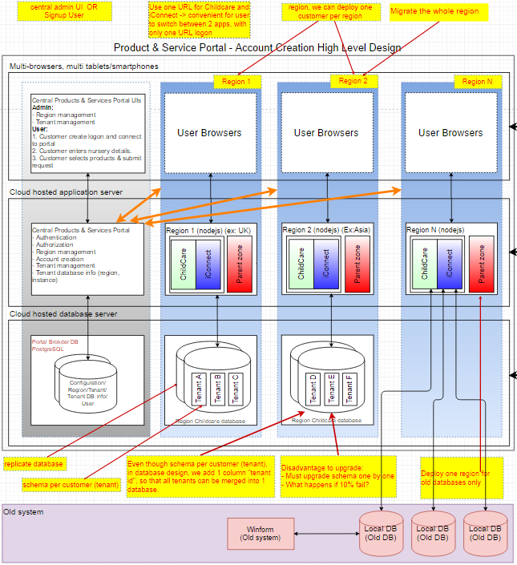

- We are going to design “tenantId” as an optional column. It means the system can work with both old databases and new databases, by configuration.

About deployment, a specific region does not support both old databases and new databases. We just deploy some specific regions, which interact with old databases only. And the other regions just interact with new databases only. By configuration, we can turn on/off “tenantId” for a region.

- For some new introduced modules such as Audit Trail, we design the audit trails is as a separated service, which contains a separated database. We have some benefits:

* Improves the isolation: the audit trail is an independent service.
* Eliminates long-term commitment to a single technology stack.
* Makes it easier for a new developer to understand the functionality of a service.
* Good for performance: the audit trail does not slow down the core business function. We can apply bulk insert to improve performance of audit trail service.

1. 14. Where do you anticipate hosting the database for development and the pilot?

[TMA] Basically, we will have 4 environments: Development, Testing, Staging and Production Environment.

* Development Environment: We will host the MsSQL Server on local PC/server.
* For Testing we will host it in TMA VM infrastructure. We also could provide public IPs for accessing the pilot project output via internet. And especially, no cost for hosting.
* For Staging & Production: Connect Software will provide environment.

For pilot project, we think that we just need Development and Testing environment as above.

1. Could you use Connect's SVN repository for version control as both Connect and your company will be working on the same version of DB/API code?

[TMA] we could have two options.

**Option 1.** Connect Software & TMA developers could use current Connect Software SVN repository.

To do that, we need:

* We must setup VPN connection between TMA and Connect Software. TMA has experience IT supporter to provide the setting. The VPN connection will allow private channel, confidential connection.
* Using SVN repository in both sites could cause side effect from submits to other tasks such as broken the builds. To prevent mostly side effects, we need
  + Setup CICD server (Hudson or Jenkin for example) for making build then running test every submit to very early detect the changes submitted by any members. The build status will help to notify immediately to developers for taking corrective actions as soon as possible.
  + Define the code review process with two sites review such as TMA Leads review first then Connect Technical Lead review before committing the changes into. The Unit-Test is a must before the code is sending to review.

What challenges may this cause?

[TMA] The challenges with shared SVN repository will be:

* Since the VPN connection will be the only one tunnel to check out/in the code, it will be risk if the tunnel is down or slow.
* There will be bottleneck at reviewers (both TMA and Connect Software Leads) who take reviews many items at the same time. Some late review will cause many tasks of other developers delay.

**Option 2.** We could switch current SVN repo to GIT repo (local GIT at Connect Software and TMA access via VPN) or Cloud GIT private repos (BitBucket/GitHub) . With GIT, we could have better branching and better review/merging mechanism for parallel working. GIT allows us to create release branches, private branches, hotfixes branches and have good review approach with Pull request.

What challenges may this cause?

[Answer] The challenges below with shared GIT repository will be:

* All developers both site will switch to work on GIT
* Since VPN is also used for this option, it still have risk if tunnel is down or slow.
* The bottleneck for Pull request then merging the change is less happening than SVN repo since the changes are in private repo, not affect much to other works.

1. How are translations for the multi-language to be created? We envisage this being done by linguists with limited IT technical skills.

[TMA] For end users, we store all texts in an Excel, for all languages. End-user can translate or edit this Excel file. Then, we have a developed tool to create resource file for programming. Technically, each language is stored in a language property file. It loads dynamically based on the settings. The default language property file will be provided to linguists to translate to equivalent languages, the provide back the translated files to Technical/Translation leads review the terms before applying for using.

Below is example of many languages in many column of Excel file.

|  |  |  |  |
| --- | --- | --- | --- |
| Key | English | French | Japanese |
| user_email | Email | Email | メール |
| user_password | Password | Mot de passe | パスワード |
| message_save_confirm | Are you sure you want to save? | Voulez-vous vraiment enregistrer? | 保存してもよろしいですか？ |